Title: Crisis Recognition and Response
Recommended Time: 2–3.5 hours (depending on inclusion of Optional Learning Activities)
Primary Audience: Patrol Officers
Module Goal: Through classroom instruction and discussion, the student will learn basic skills of how to recognize and respond to a person in behavioral crisis. The student will be able to identify key behaviors and learn some basic tips and techniques to help defuse critical incidents involving persons in crisis and move toward a safe resolution. (Note that more detailed and specific communication and tactical strategies are covered in Modules 4 and 5.)
Required Materials: Digital presentation (Power Point and video); lesson plan
Learning Objectives: At the completion of this course, students will be able to:
  - Successfully identify behaviors associated with a person experiencing behavioral crisis.
  - Recognize principles and best practices for effectively responding to a person in behavioral crisis.
  - Use some common tips and techniques for engaging and making a connection with a person in behavioral crisis.
  - Describe and recognize the value of the emotional–rational thinking scale.

Notes: For officers who have completed Crisis Intervention Team (CIT) or similar in-depth training, the material in this module will be familiar and quite basic. However, those officers should be encouraged to actively participate in this module, as the skills covered in CIT training still need to be reinforced. As appropriate, instructors should call upon CIT-trained students to help discuss and amplify key lessons in the module.

Agencies might consider co-teaching this module with 1) local mental health professionals who have worked closely with the police and/or 2) experienced officers who have used their crisis intervention training and skills to successfully defuse and resolve critical incidents involving persons in behavioral crisis. (See Learning Activities 3 and 4, pp. 22-23, for additional background and suggestions.)

Recommended Time Allocation
 | Unit | Recommended Time  (minutes)
1 | Learning Activity–1 (Assessment) | 20
2 | Recognizing Someone in Crisis | 30
3 | Responding to Someone in Crisis | 40
4 | Learning Activity–2 (Video Case Study) | 20
5 | Learning Activity–3 (Community Mental Health Engagement – optional) | 60*
6 | Learning Activity–4 (Officer Experiences – optional) | 30*
7 | Recap and Discussion | 10
Total |  | 120-210*

* Overall time estimates are dependent upon the inclusion of the optional Learning Activities.

Table of Contents

- Learning Activity–1 (Assessment) 4
- Recognizing Someone in Crisis 5
- Responding to Someone in Crisis 11
- Learning Activity–2 (Video Case Study) 20
- Optional Learning Activity–3 (Community Mental Health Engagement) 22
- Optional Learning Activity–4 (Officer Experiences) 23
- Recap and Discussion 24

Overview: Incidents involving persons in behavioral crisis present a unique and difficult challenge for the police, and these types of calls appear to be growing. How these cases are handled can have significant short- and long-term consequences not only on the individuals and their loved ones, but also on officers, their agencies, and their relationship with the community. In recent years, through programs such as Crisis Intervention Team (CIT) training, police agencies have recognized the importance of these situations and have provided specialized training to many police officers.

This module is not intended to replace the specialized instruction provided through CIT or other programs. Rather, this module is intended as a general overview of crisis recognition and response, which can be augmented by more specialized training such as CIT. This module is specifically designed to help the initial patrol officers arriving on a scene involving a person in behavioral crisis to slow down and attempt to stabilize and defuse the situation (whenever possible), with the goal of moving it toward a safe and peaceful resolution through voluntary compliance. Often this is achieved with the assistance of CIT-trained officers, other specialized police personnel, and even other agencies, once they arrive on scene. Still, the initial responding officers require the tools and skills needed to stabilize and manage the situation until those additional resources arrive.

While this module is not “CIT training,” it does touch on a number of issues related to mental illness. To the extent possible, agencies should try to include specially trained subject matter experts, from within or outside the department, in the customization and delivery of this training.

- Learning Activity–1 (Assessment)
Instructor Notes
SLIDE #1
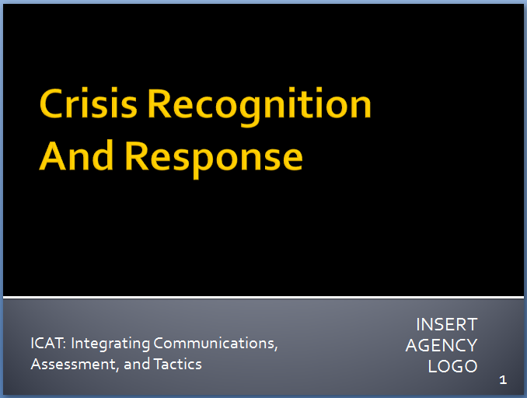

SLIDE #2
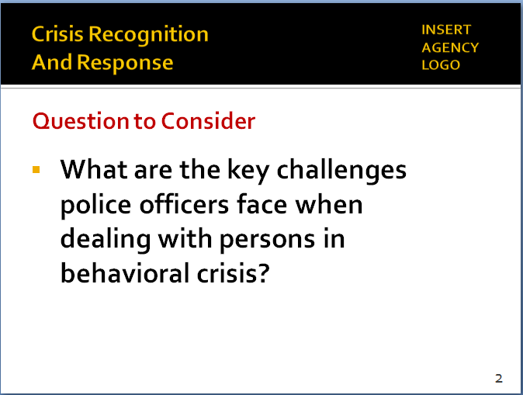
Activity: Assessment Group Project
Activity Time: 20 minutes
Activity Learning Objective: An assessment exercise that serves as an introduction to the Crisis Recognition/Response module
Required Equipment: Easel pads, markers
Facilitator Instruction: Break the class into small groups. Provide each group with markers and easel pads. Each group will have 10 minutes to brainstorm and chart responses to this question: “What are some of the key challenges police officers typically face when dealing with persons in behavioral crisis?” Each group will delegate a spokesperson who will present the findings to the class.
- Recognizing Someone in Crisis
When someone is in crisis there is often a precipitating event, and the individual is unable to resolve the crisis using normal coping methods. When an individual is in crisis, he or she often experiences heightened emotionality and lowered rational thinking. The person in crisis will begin to experience psycho-physical arousal which in turn may bring about physiological changes. This crisis may be a result of mental illness, as well as people suffering from substance abuse or personal crises, or a combination of factors.

Recognizing the signs of a person in crisis is a necessary first step to effectively responding to that person. Patrol officers are not expected to be able to clinically diagnose a person in crisis. However, officers are more effective during critical incidents, and can achieve safer outcomes, when they can recognize and identify the common signs that a person they encounter may be in crisis.
  - What is a “behavioral crisis?”
    - An episode of mental and/or emotional distress that is creating instability or danger and is considered disruptive by the community, friends, family or the person him/herself
Instructor Notes

SLIDE #3
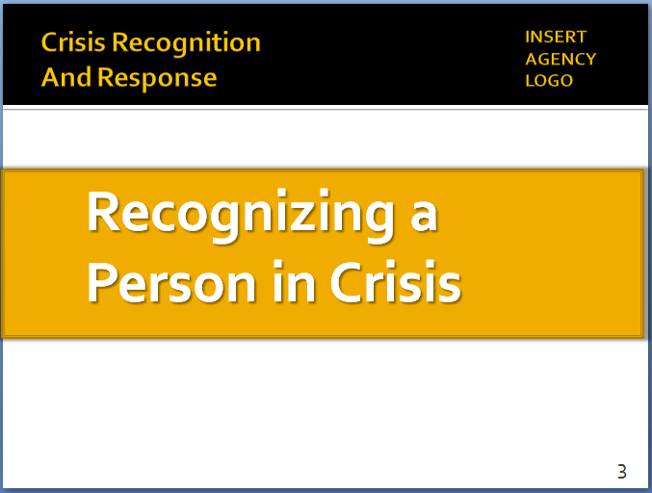

SLIDE #4
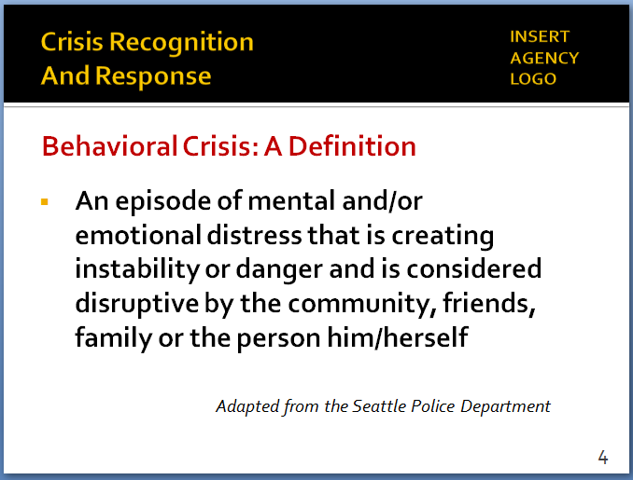
From the Seattle Police Department
Another definition of “crisis”
A real or perceived set of circumstances that makes a person feel that they are unable to appropriately resolve their situation (Police Training Institute, Univ. of Ill.)

SLIDE #5
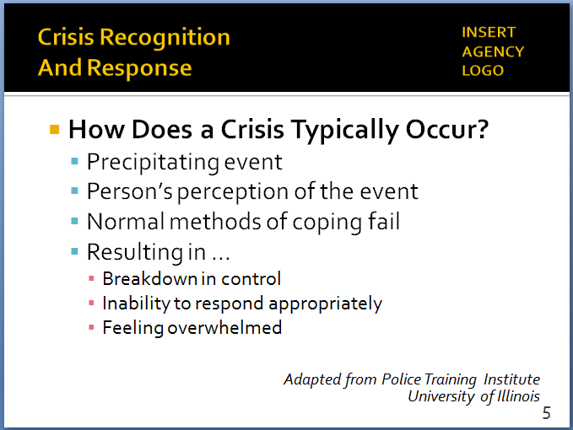
Each crisis is unique. A situation might occur to numerous people but won’t be a crisis for everyone. PERCEPTION SHAPES AN INDIVIDUAL’S REALITY.
    - Three key factors:
      - It’s episodic – a unique event
      - Creates instability or danger
      - Other people (or even the individual in crisis) consider it disruptive – and sometimes dangerous
    - That’s why people call the police (and not EMS or mental health) when they encounter someone in crisis
    - The police response to a person in behavioral crisis is different, more complicated
  - How does a crisis typically occur?
    - Often a precipitating event (death of a loved one, violence, divorce, job loss, mental illness, reaction to/stopping medication)
    - The person’s perception of the event – which can be accurate, erroneous, or somewhere in between
    - Normal methods of coping/solving problems fail
    - Resulting in …
Instructor Notes

SLIDE #6
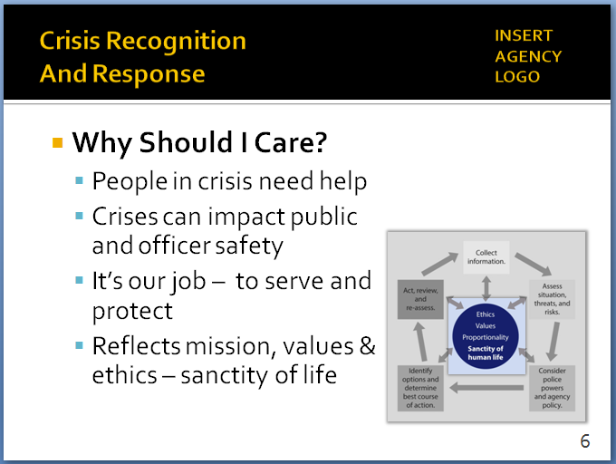

SLIDE #7
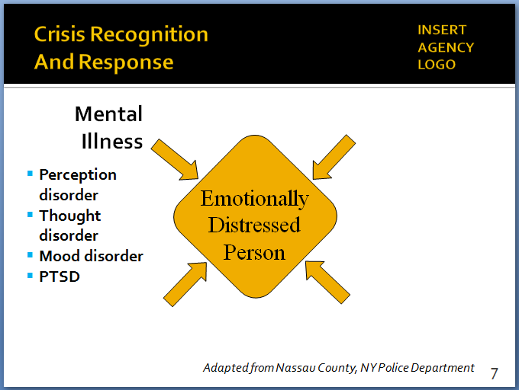
Adapted from the Nassau County, NY Police Department

Some agencies use the term “Emotionally Disturbed Person;” however, the term “Distressed” is preferred
Glossary of terms related to “first episode psychosis”: https://www.nimh.nih.gov/health/topics/schizophrenia/raise/glossary.shtml

For more on PTSD: https://www.nami.org/Learn-More/Mental-Health-Conditions/Posttraumatic-Stress-Disorder

SLIDE #8
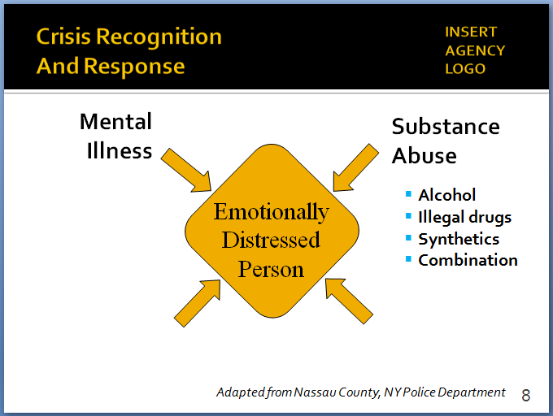

      - A breakdown in control
      - Inability to respond appropriately
      - Often feeling “overwhelmed”
  - Why should I care?
    - Because people in crisis need help
    - Because crises can impact public and officer safety
    - Because it’s our job – to serve and protect everyone
    - Gets back to the core of the Critical Decision-Making Model – our mission, values and ethics
  - “Person in crisis” sometimes referred to as an
EDP (or Emotionally Distressed Person) –
Four types of possible contributing factors …
    - Mental illness, including …
      - Perception disorder (or hallucinations) – hearing, seeing, touching, smelling or tasting things that are not real
      - Thought disorder (or delusions) – false beliefs that have little or no basis in reality
      - Mood disorder – emotional extremes, violent swings, flatness
      - PTSD – flashbacks, frightening thoughts/dreams, hyper arousal, avoidance, disassociation (out-of-body experiences)
        - May try to cope through drinking, drug abuse
        - Can be significant issue in military communities
    - Substance abuse
      - Alcohol
      - Illegal drugs
      - “Synthetic” drugs
      - Combination of substances
    - Medical condition
Instructor Notes

SLIDE #9
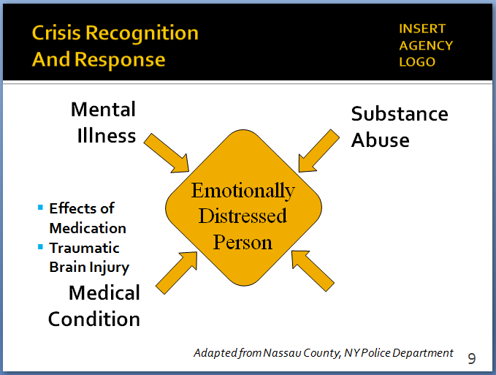
TBI is a serious public health problem—an estimated 2.5 million incidents a year. For more information, http://www.cdc.gov/traumaticbraininjury/get_the_facts.html and http://www.mayoclinic.org/diseases-conditions/traumatic-brain-injury/basics/symptoms/con-20029302

SLIDE #10
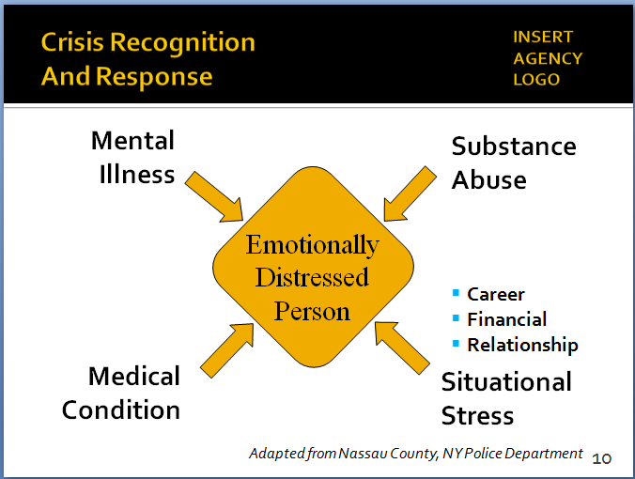

SLIDE #11
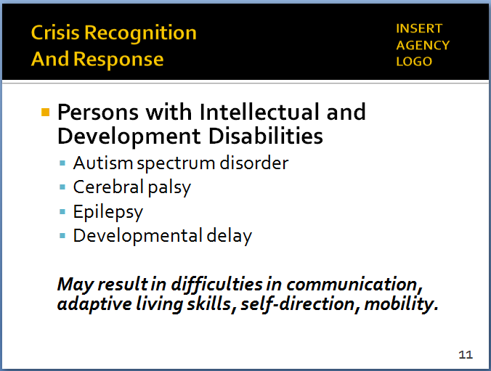

For an overview of intellectual and development disabilities, https://www.nichd.nih.gov/health/topics/idds/Pages/default.aspx

      - Including side effects of medication
      - No longer taking medication
      - Traumatic brain injuries (TBI)
        - Injury may be obvious (open head wound) or less obvious (closed head wound)
        - Symptoms include being dazed, confused, disoriented; fatigue; dizziness/loss of balance; confusion; agitation/combativeness; unusual behavior; difficulty communicating/ processing information
        - Creating big challenges for police officers
    - Situational stress
      - Job loss
      - Financial troubles
      - Relationships
    - Or it can be a combination of these factors – this can especially challenging for the police
  - Important to remember that not everyone behaving erratically is suffering from emotional distress – there are other factors that officers need to consider …
    - Intellectual and developmental disabilities
      - Disorders usually present in birth that negatively impact a person’s physical, intellectual and/or emotional development into adulthood, and require support
      - Common examples:
        - Autism spectrum disorder
        - Cerebral palsy
        - Epilepsy
        - Developmental delay
      - May result in difficulties in life areas, such as communication, ability to learn, adaptive living skills, self-direction, self-help, and/or mobility
Instructor Notes

SLIDE #12
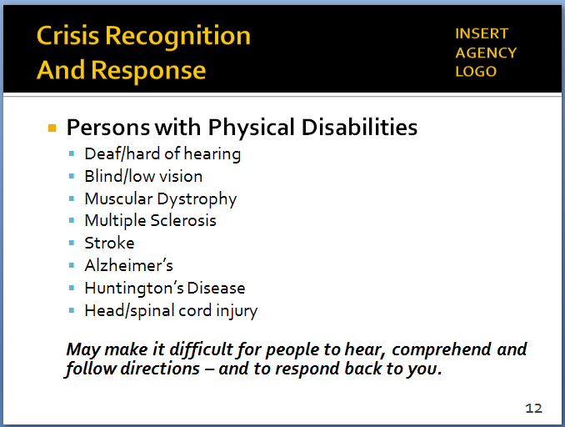

For general information on physical disabilities, http://hwa.org.sg/news/general-information-on-physical-disabilities/

      - Common police calls (often no crime involved):
i. Walking into traffic
ii. Entering homes/looking into windows
iii. Wandering
iv. Rearranging store displays
v. Following customers around a store
      - May be attracted to shiny objects, overly sensitive to light, sound or touch
      - May run from the police or display erratic behavior because of fear, not necessarily because they committed a crime
    - Physical disabilities
      - A disabling condition or other health impairment that requires adaptation
      - Can be congenital, acquired with age, or the result of an accident
      - Some common examples:
        - Deaf/hard of hearing
        - Blind/low vision
        - Muscular Dystrophy
        - Multiple Sclerosis
        - Stroke
        - Alzheimer’s
        - Huntington’s Disease
        - Traumatic neurological disorders

      - Physical disability may make it difficult for a person to hear, understand and follow directions
      - Communications may not work – not because the person is defiant or non-compliant, but because they can’t hear or comprehend, and can’t respond back to you
    - Persons with physical and/or developmental disabilities may exhibit some of the same unusual or erratic behaviors as EDPs
      - Don’t assume someone behaving erratically suffers from mental illness
      - It could be one of many factors – or a combination of factors
  - Focus on the subject’s behavior, which can provide important clues. Is he or she …
    - Responding to dialogue/verbal commands?
    - Coherent? (Or talking in “word salad?”)
    - Able to make eye contact?
    - Agitated? (Shouting, pacing, talking to people not there)
    - Talking to themselves?
    - What is the state of their hygiene and clothing
    - Environmental factors (e.g., overflowing trash, aluminum foil on windows, etc.)
- One other effective (but often underutilized) approach to recognizing someone in crisis – Ask!
Instructor Notes

SLIDE #13
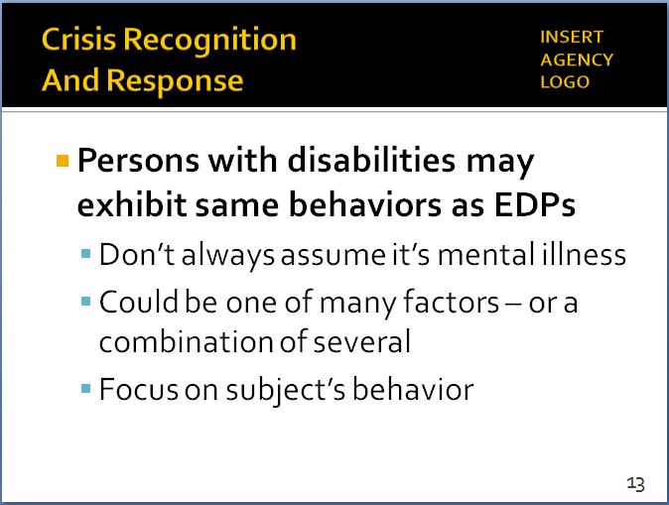

SLIDE #14
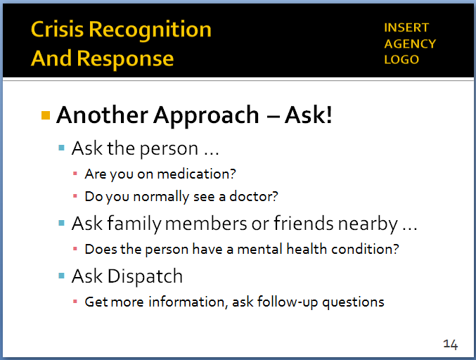

  - If the situation lends itself, ask the person questions such as …
      - Are you on medication?
      - Do you have a doctor you normally see?
      - How can I help with what’s bothering you?

- Ask family members or friends nearby …
Instructor Notes

SLIDE #15
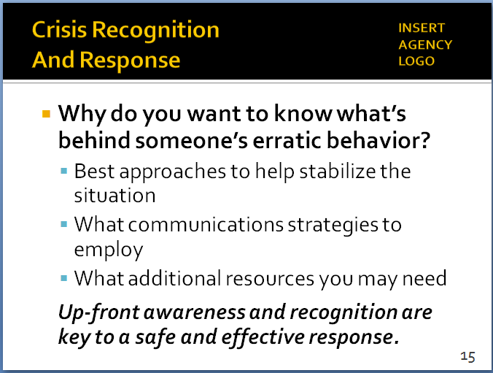

Crisis recognition is part of Step #1 in the Critical Decision-Making Model: Collect Information.

As with CIT training, officers are not expected to become expert clinicians. Rather, we are trying to understand mental health issues and indicators for the purpose of having an effective response/communication strategy.

- Does the person have a mental health condition?
- A physical or development disability?
- What might the person respond to positively?
- Ask the Dispatcher to get more information from the caller or previous call history
- Why do you want to take the time to try and understand what’s behind someone’s erratic behavior? Because that information can help you figure out …
  - What approaches might work to help stabilize the situation
  - What communication strategies to employ
  - What additional resources you may need to resolve the situation
  - Up-front awareness and recognition are key to coming up with a safe and effective response

- Responding to Someone in Crisis
For the first responding officer on the scene, the mission is not to diagnose the person in crisis or try to counsel him or her to an immediate resolution. Rather, it is to assess the situation and make it safe; attempt to defuse the crisis as much as possible; buy time for specialized resources to arrive; and try to get the subject to a state where he or she can make more rational decisions, resulting in a safe and peaceful resolution through voluntary compliance. Specific communication and tactical skills are covered in future modules. This unit focuses on how to approach the initial response.
  - What the encounter looks like from the other perspective
Instructor Notes

SLIDE #16
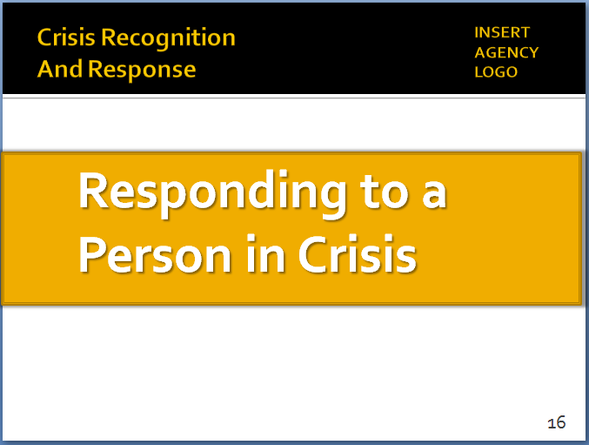

SLIDE #17
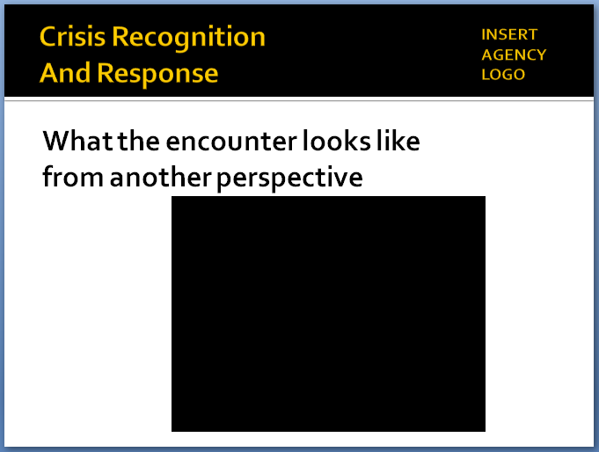

For video, transcript and comments, go to: http://www.pbs.org/newshour/bb/this-is-what-its-like-to-be-arrested-while-suffering-mental-illness/

For background on Paton Blough and Rehinge, http://rehinge.com/

    - Set up video
      - Paton Blough suffers from Type 1 Bipolar disorder, which he didn’t discover until age 26
      - For years, he experienced manic episodes that led to various encounters with the police (6 arrests)
      - Now in recovery, he speaks about those incidents
      - This is a 2016 video essay he did for PBS
    - Play Paton Blough video
- Discuss briefly – possible comments to explore:
- “Rules of society don’t apply to me when I’m having one of my episodes.”
  - “You can imagine the kind of reaction someone like me might have when delusions trigger an incident in which a police officer wants to engage with me or, worse, arrest me.”
  - “The other three (arrests) were extremely violent, because, in my head, I was fighting for my life.”
  - “One time, I was arrested by an officer who I believed naturally possessed many of the things we train. He slowed down and didn’t force the issue.”
  - “Make the person feel they’re in control – slow down and stay calm.”
- Some facts about people with mental illness
Instructor Notes

SLIDE #18
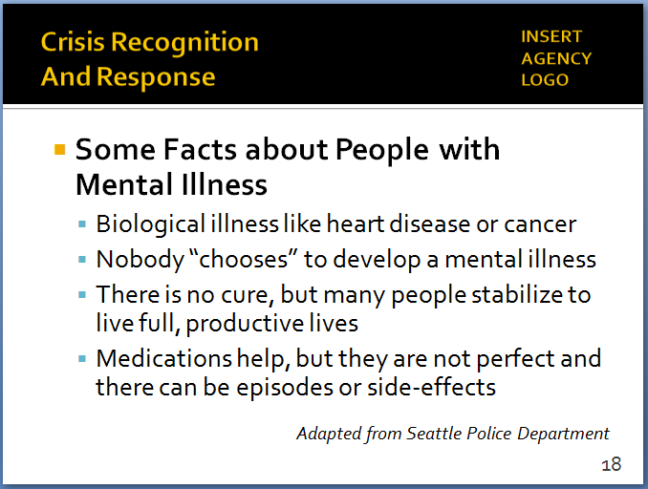

SLIDE #19
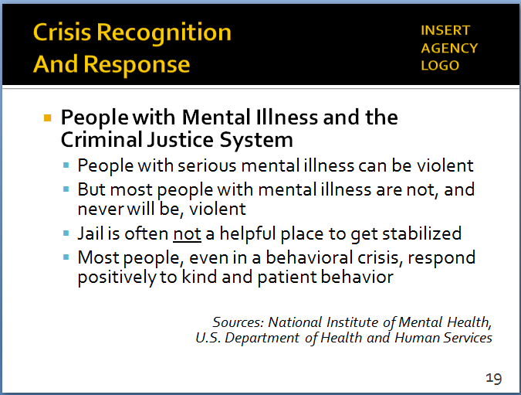

Source: https://www.nimh.nih.gov/about/director/2011/understanding-severe-mental-illness.shtml

Source: https://www.mentalhealth.gov/basics/myths-facts/

Police officers are likely to see people when they’re at their worst – in the most serious of crises. Officers are not necessarily seeing a true cross-section of people with mental illness. Encounters with people with serious mental illness can be dangerous. But that doesn’t mean every person with mental illness is violent and dangerous.

- Mental illness is a biological illness just like heart disease, cancer or diabetes
- Nobody “chooses” to develop a mental illness – one in four families is affected
- There is no cure, but many people stabilize to live full, productive lives
- Medication plus therapy can be effective, but side effects of medication can potentially cause crises and erratic behavior
- Mental illness and the criminal justice system
- People with serious mental illness (SMI) can be violent, especially when experiencing a psychotic episode
  - One study: people with SMI are up to three times more likely to be violent than general population
  - When SMI is associated with substance abuse, the risk may increase much further
- But most people with mental illness are not violent and never will be
  - About 3-5% of violent acts can be attributed to someone with a serious mental illness
  - People with mental illness are 10 times more likely to be victims of violent crime than the general population
- Jail is generally not a helpful place for someone to get stabilized
  - Only a small percentage of people with mental illness have committed a crime or qualify for an involuntary evaluation

  - Don’t approach an encounter thinking it will be “solved” if you can get the subject in custody as quickly as possible – a temporary band-aid at best
  - Person will likely be back in the community and you will likely have to respond again
- What is “Crisis Intervention?”
- A process to assist individuals in finding safe and productive outcomes to unsettling events
- As first responding officer, you’re one (very important) part of the crisis intervention process
Instructor Notes

SLIDE #20
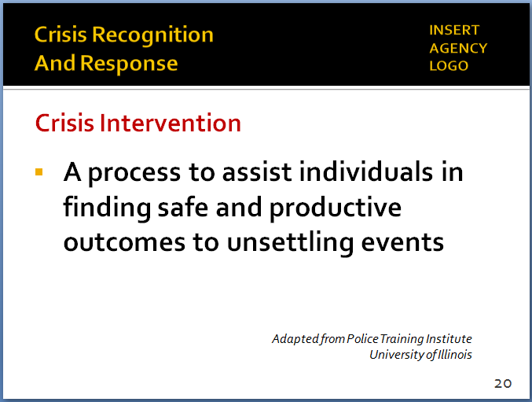

Verbal de-escalation: use of words and actions to reduce a heightened emotional and physical state, in order to facilitate calm, rational interaction (Seattle Police Department)

SLIDE #21
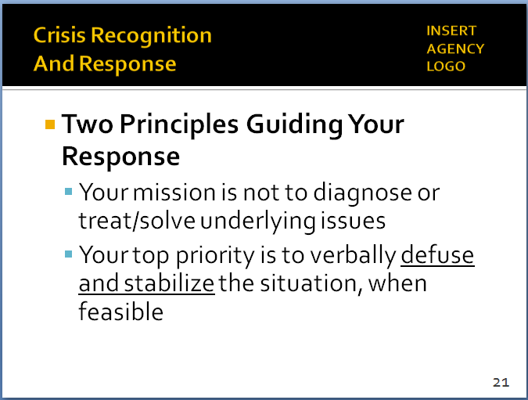

Note: many of the communication skills touched on here are covered in much more detail in the next Module (Module #4: Tactical Communications).

      - The subject’s first interaction with police is critical
      - You set the tone and help chart the course toward a resolution
- But you (by yourself) are not the entire process
      - Your role is not to “solve” the underlying crisis
      - It is to stabilize the situation, make it safe, help get the person in a frame of mind to find solutions
      - Then, hopefully hand it over to others to provide longer-term care and solutions
- Two guiding principles to keep in mind:
- Your mission is not to diagnose the subject or treat/solve the underlying issues
      - Don’t assume you have correctly diagnosed the person
      - Don’t assume you know what to do based on your “diagnosis”
- Top priority (when feasible) is to verbally defuse and stabilize the situation as much as possible
      - Try to get the person to a state where he or she can function and reason a bit better
      - Where voluntary compliance can be achieved
- Emotional – Rational Thinking Scale
Instructor Notes

SLIDE #22
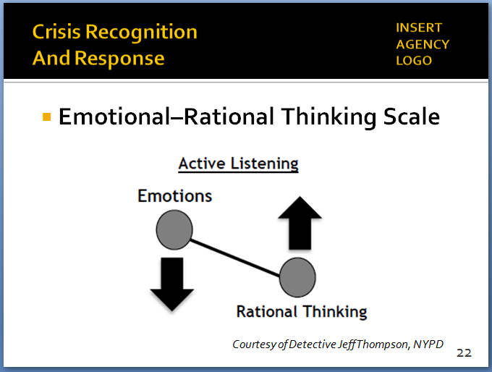
Concept/graphic courtesy of Detective Jeff Thompson, NYPD

This same phenomenon applies to officers as well. Keeping your emotions in check serves to enhance your rational thinking.

SLIDE #23
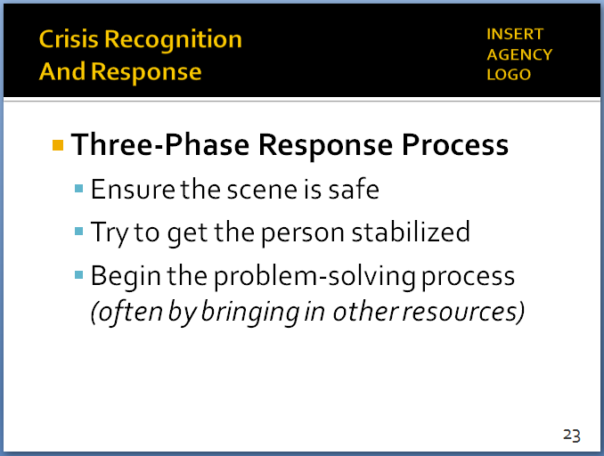
This process corresponds with CDM steps 2 and 4 (assessing threats/risks, determining best course of action).

SLIDE #24
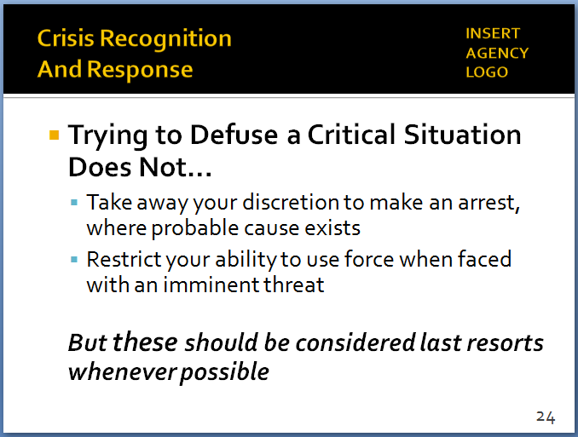

    - Decision-making gets clouded by emotions – people can’t make good, rational decisions when they are overly emotional
    - As emotionality goes down, rationality goes up – this results in better, more logical decision-making
    - As the first responding officer, you should focus on:
      - Trying to recognize where the person may be on this scale
      - If out of balance, then working to lower emotions, raise rational thinking
- Three-phase response process when faced with a person in crisis
- Safety – of the public, the subject, the police
- Stability – try to get the person stabilized through verbal and non-verbal de-escalation techniques
- Problem solving (eventually)
      - As much as possible, try to get the person to a state of rational thinking/decision-making
      - Increases the likelihood of voluntary compliance and incident resolution
      - Again, this may require additional specialized resources – within and outside your agency.
- Trying to defuse a critical situation does not …
- Take away or restrict your discretion to make an arrest, where probable cause exists
- Take away or restrict your ability to use reasonable and proportional force when faced with an imminent threat
- But these should generally be considered last resorts – when other approaches have been tried and failed
- How to approach persons in crisis – some practical tips and techniques:
Instructor Notes

SLIDES #25-26
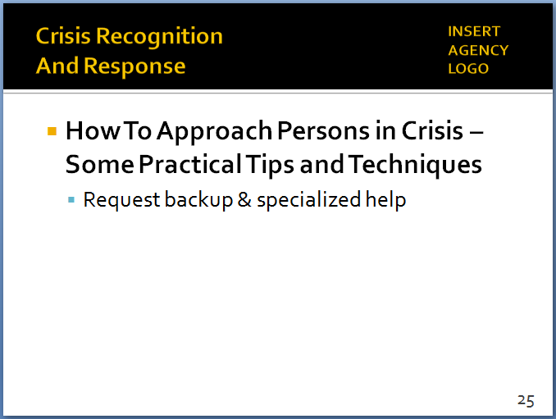
NOTE: These are “build” slides. Each mouse click displays the next bullet.

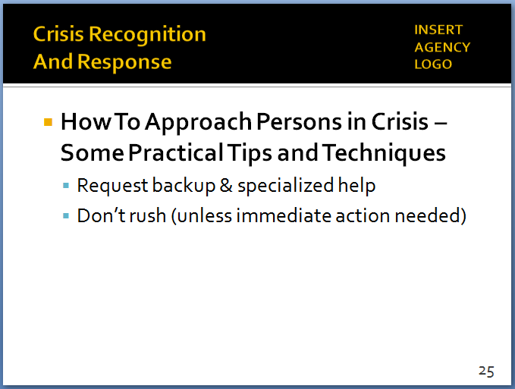

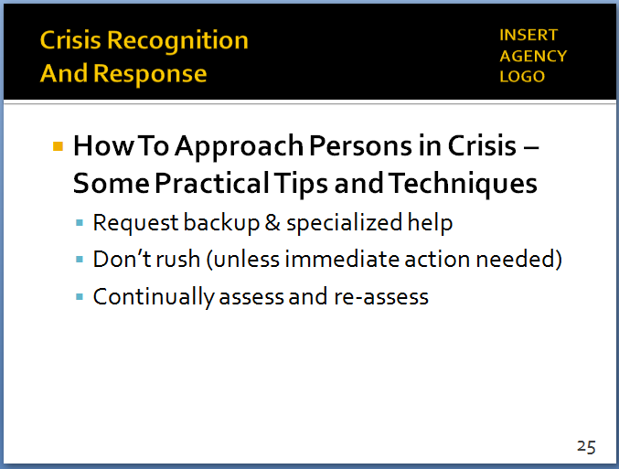

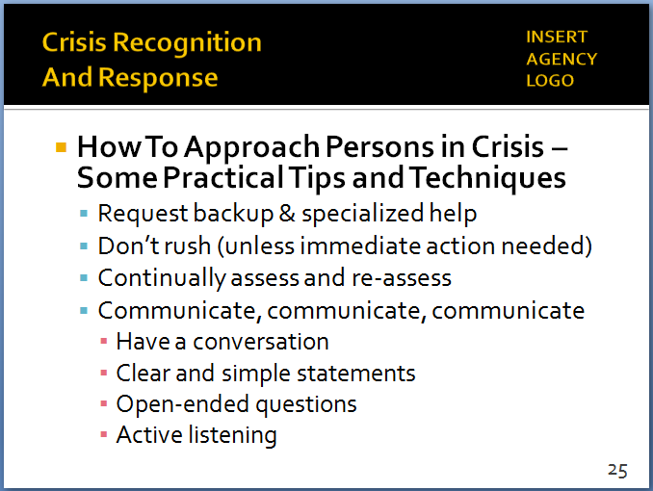

Many of the communication skills touched on here are covered in much more detail in Module #4 (Tactical Communications).

Tactical tip: It’s also important to make sure you are communicating with your partners and other personnel on the scene.

- Request backup and specialized help
  - CIT-trained officers
  - Local mental health partners
- Don’t rush into situations (unless immediate action is required)
      - Move slowly
      - Focus on calming the situation
      - Minimize the stress level
- Continually assess – and re-assess
      - As the subject’s demeanor and actions change, be prepared to adjust your approach
      - “Spin the CDM model”
- Communicate, communicate, communicate
      - Put yourself in a position to have a conversation, not a situation where all you can do is bark commands
        - Start by saying “hello” and introducing yourself
        - Then ask how you can help
      - Clear and simple statements
        - Shouting commands is often counterproductive to someone in crisis
        - No more than one command/question at a time – and allow the person time to answer
        - Don’t make threats
- Ask open-ended questions to initiate dialogue
- But avoid leading questions
- When needed, yes/no questions can elicit specific information (e.g., “Are you taking any medications?”)
- Active listening
- Show the individual you hear what they are saying – reflect back their thoughts & feelings
- Don’t take it personally if the subject doesn’t respond/obey
Instructor Notes

Again, the specific techniques of active listening are covered extensively in Module #4.

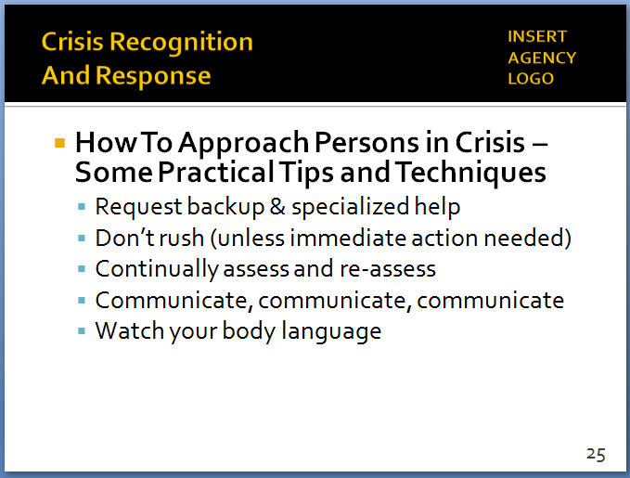

Additional information on non-verbal communication is contained in Module 4.

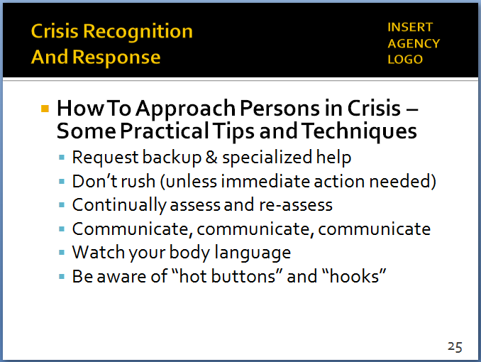
“Hot buttons” and “hooks” are featured prominently in the scenario-based training exercises.

The term “hot buttons” is adapted from FBI and NYPD training.

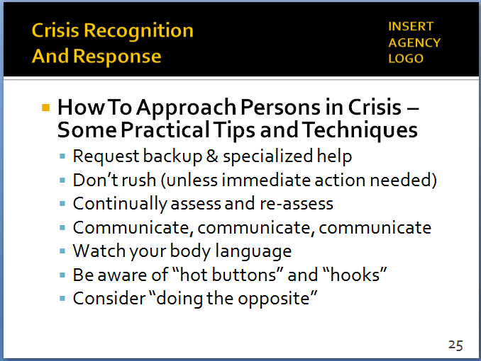

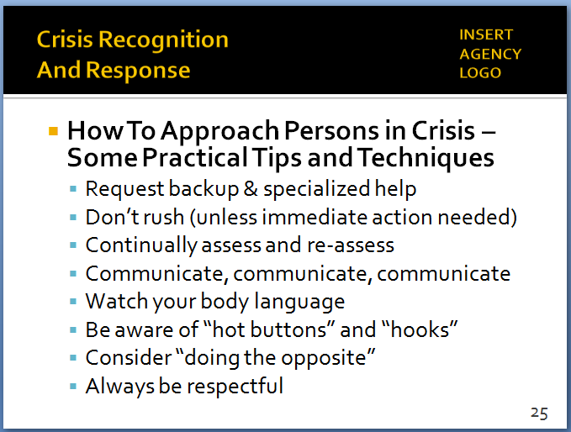

Remember what Paton Blough said: pretend the person you are dealing with is a relative or close friend.

- He/she may not hear or understand you
- Watch your body language
      - People in crisis may not understand your words, but they can often read your tone and body language – sense whether you care about them
      - Be sincere and compassionate – display empathy
      - Respect the person’s “personal space”
      - Recognize your presence may cause agitation – don’t take it personally; leave ego in your locker
- Be aware of …
      - “Hot buttons” (or “Triggers”): topics that may further agitate the subject – avoid them
      - “Hooks”: topics that may help to calm the subject – leverage them to your advantage
- If person in crisis is displaying one behavior type, consider doing the opposite
      - If they are yelling, be calm
      - If they are “flat-lining,” be more assertive
- Always be respectful, never dismissive
      - Don’t say things like “calm down” or “just take your medications”
      - Display ethical leadership
        - You’re in control of the situation
        - Exercise that control with empathy and respect

- Goal: Make a connection with the subject … so as to work toward voluntary compliance
- Even in the middle of a crisis, most people respond positively to kindness, patience and respect
- “Tactical empathy” (not the same as “sympathy”)
  - Never compromise your tactical position
  - But put yourself in a safe position to make that connection
- Not only can defuse a situation – can also help prevent unnecessary escalation
Instructor Notes

SLIDE #27
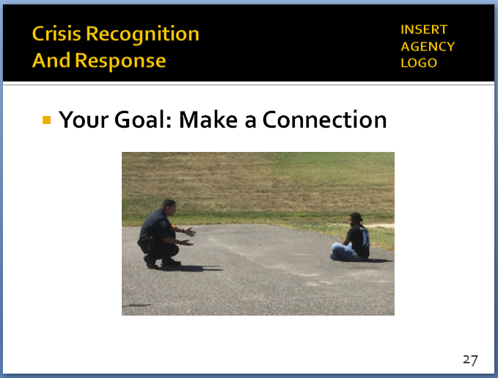
This photo is from a scenario at the Camden County (NJ) Police Department, which was one of the ICAT pilot training sites.
Students may want to discuss the officer’s position (crouched) and distance.

SLIDE #28
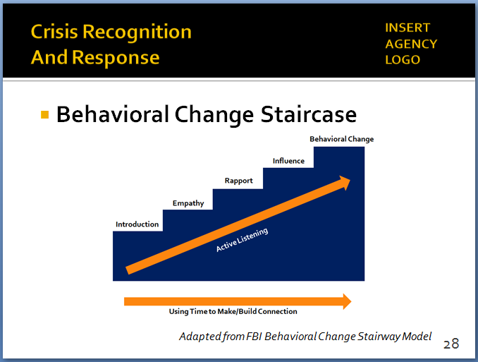

Adapted from the FBI Behavioral Change Stairway Model. For more background, see https://viaconflict.wordpress.com/2014/10/26/the-behavioral-change-stairway-model/ and http://www.mediate.com/articles/ThompsonJbl20131304.cfm

Another (somewhat simpler) approach used by the NYPD is the Law Enforcement Negotiation Stairway Model (LENS)

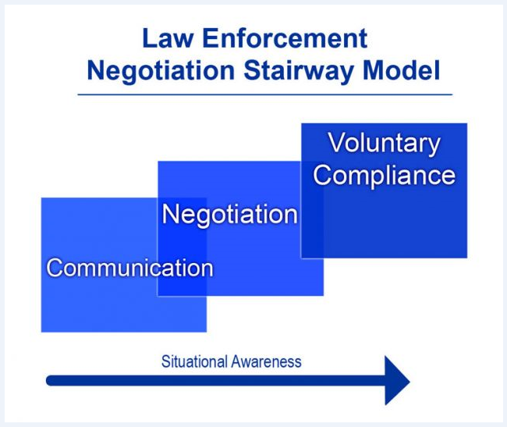

- When officers connect, you can influence behavior
- Behavioral Change Staircase
  - FBI training tool for negotiators
  - Can be used effectively by patrol officers as well – a fancy name for something many of you practice every day
  - Five steps toward voluntary compliance
    - Introduction
    - Empathy
    - Rapport
    - Influence
    - Behavioral change
  - First three steps are about connecting with the subject
  - Last two steps are about problem-solving
  - Active listening is critical throughout the process

- Some things not to do
Instructor Notes
SLIDE #29
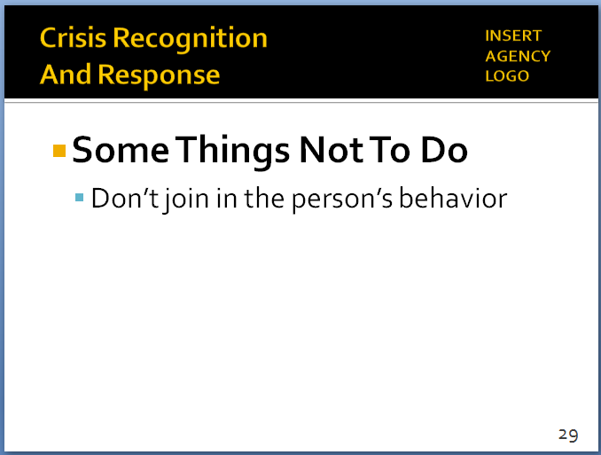
NOTE: This is a “build” slide. Each mouse click displays the next bullet.
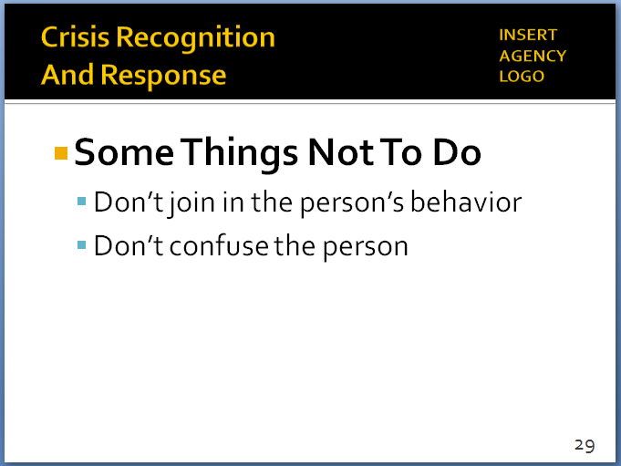

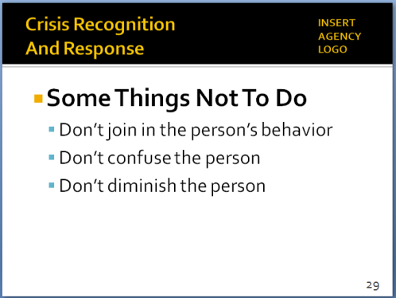

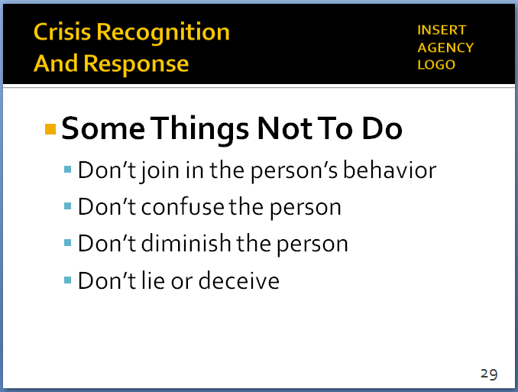

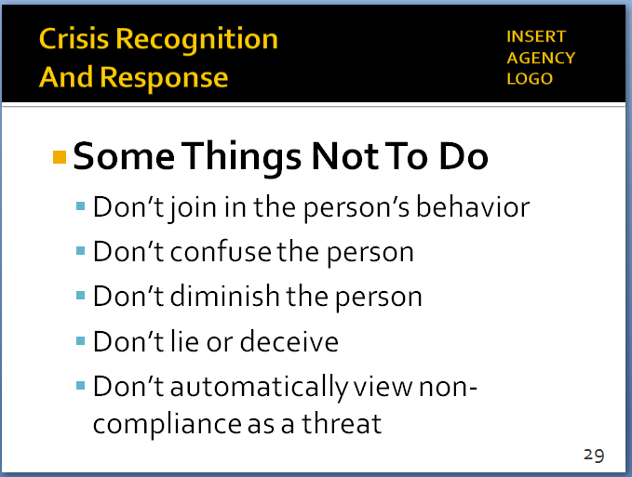
- Don’t join in the subject’s behavior
  - If they’re agitated, you need to remain calm
- Don’t confuse the subject
  - By issuing multiple commands or complex choices
  - Keep your communication simple
  - Allow time for answers
- Don’t diminish the subject
  - By whispering, joking or laughing
    - Can make the person suspicious or scared
    - Can feed into their anxiety/fear/paranoia – this can escalate their behavior
  - Subject may feel he or she is not being taken seriously
- Don’t lie or deceive
  - If you’re caught in a lie, you might never recover
  - Won’t be able to move up the Behavioral Change Staircase
- Don’t automatically view non-compliance as a threat
  - There are many reasons subject may not be following your directions (can’t hear, comprehend, process information)
  - Stay focused on the subject’s behavior and communication back to you
- Remember … everything you do impacts all future contacts the individual in crisis (and maybe family and friends) have with the police
  - Don’t make it harder for the next officer by taking shortcuts or treating someone poorly
- Finally … manage your own reactions
Instructor Notes

SLIDE #30
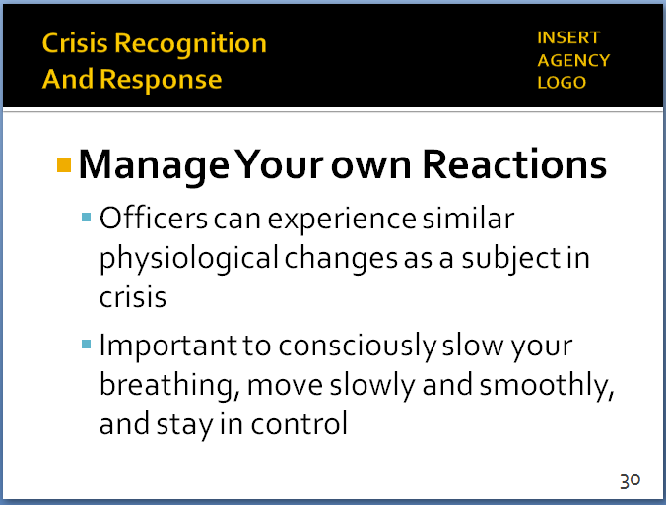

.
- When faced with a subject in crisis, officers can experience some of the same physiological changes the subject is going through
      - Rapid heart rate – adrenaline rush
      - Increased breathing rate – shallower breaths
      - Increased muscle tension
      - Rapid eye movement and “tunnel vision”
      - Auditory exclusion
      - Amygdala Hijack (emotional redlining)
    - Important for officers to consciously:
      - Slow breathing (inhale-hold-exhale on 4 count)
      - Stay as calm as possible
      - Keep good posture
      - Use eye contact
      - Move slowly and smoothly
      - Stay in control
    - You can say all of the “right” things … but if you appear afraid, irritated, or angry, verbal communications will have little effect on defusing the situation
    - Your words need to match your body language and demeanor

- Learning Activity–2 (Video Case Study)
Instructor Notes

SLIDE #31
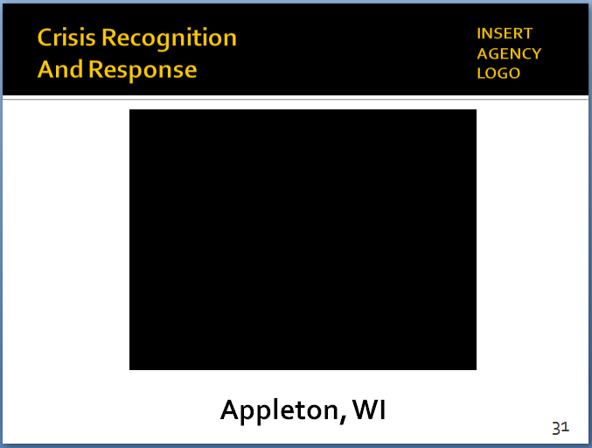

Video available at https://www.youtube.com/watch?v=jizOcTUlfV4

We will have other videos later in the training where this level of information was not collected, asked for, or relayed to responding officers.

Note

This exercise is to illustrate how one officer used some of the tips and techniques that are covered in this module to respond to a person in crisis. The video also illustrates some of the important elements of the Critical Decision-Making Model.

A few reminders:
- Set up the video ahead of time; provide background and context.
- Remind students that the video is not “perfect;” the purpose is not to judge or second-guess the officer’s actions or render a grade. Rather the video illustrates the real-world challenges officers face. The purpose is to generate discussion on how these challenges can be handled as safely and effectively as possible. We are not suggesting this was the only possible course of action in this case.
- Although the video plays for 9:43, it can be stopped at about 5:02. The main learning points are covered by then.

  - Set up the video
    - Appleton, WI
    - June 2009
    - Mother calls 9-1-1 to report her son (inside their house) is acting erratically, not making sense, is naked
    - First part of the video covers the communications traffic
  - Start the video
    - Stop at 2:50
      - What information does he have? (CDM Step #1)
      - Dispatch gathered and relayed critical information
      - Field units asked for clarification
      - Frequent updates, notifications, asking for resources

      - Supervisory response?
Instructor Notes

This is an example of a “tactical pause”—a concept discussed later in the training. See Module 5, p. 7.

Many of these points will be covered in greater detail in Module 4, Tactical Communications. However, it is probably good to introduce them and touch on them briefly here. You can refer back to his video in that Module.

Some students may wonder why the officer did not separate Tim and his mother. That is a reasonable topic for discussion, but not a major focus of this exercise.

      - Supervisor came on air and broadcast the “game plan”
      - Ensured specialized resources were in place
    - Restart the video – Stop at 5:02
- Initial approach – first impression?
- Started low – didn’t rush the action (appropriate based on the information he had)
- Asked questions – gathered more information
- Then, waited for other resources to get in place before going hands-on and securing Tim
- How was his communication?
- Reassuring messages right away (“It’s OK,” “I understand,” “You’re OK”)
- Clear, simple directions (“Tim, we need to go to the hospital.”)
- Calm, even tone of voice
- Continued to offer reassurances throughout (“We’re not going to hurt you,” “We’re going to the hospital,” “It will be OK”)
- Body language?
- Open-handed gestures
- Good presence – but still had the door available for cover initially
- Rapport building?
- Asked for and used the subject’s name
- Acknowledged, was empathetic to the mother
- Followed the subject’s lead – when Tim said he was going to lay down, the officer asked if he would lay down … Tim complied
- Anything else?
- Learning Activity–3 (Community Mental Health Engagement) – Optional
Activity: Group Engagement Exercise
Activity Time: 60 minutes
Activity Learning Objective: To directly expose students to the real-life experiences, concerns and hopes of individuals living with a mental illness through a structured presentation and question-and-answer session with a person with mental health issues
Required Equipment: Easel pads, markers; digital presentation (as needed)
Facilitator Instruction: There are a number of options for organizing this group exercise:
- NAMI “In Our Own Voice” program. The National Alliance on Mental Illness offers a free program in which local NAMI affiliates arrange for people with mental health conditions to share their personal stories. You can schedule a presentation through a local NAMI affiliate. For more information, go to https://www.nami.org/Find-Support/NAMI-Programs/NAMI-In-Our-Own-Voice.
- Local mental health department. Contact the mental health agency in your community to see if it has, or can arrange, a presentation.
- Local mental health provider community. Similarly, contact a local provider of mental health services to see if it has, or can arrange, a presentation.

Whichever approach is selected, the setting for this activity should be comfortable and conversational. The presenter should be given sufficient time to make a presentation, and there should be ample time for questions and answers. If needed, the Facilitator may need help start the Q&A. Ask appropriate questions about such things as the individual’s past experience (good and bad) with the police, how he or she feels when approached by an officer, how he or she might react to police directions or commands, and how the police can most effectively communicate and interact with you. Try to ensure that the discussion stays focused on the individual’s interactions with the police.

- Learning Activity–4 (Officer Experiences) – Optional
Activity: Group Engagement Exercise
Activity Time: 30 minutes
Activity Learning Objective: To expose students to the real-world experiences and perspectives of fellow officers who have successfully de-escalated and resolved critical incidents involving persons in behavioral crisis
Required Equipment: Easel pads, markers; digital presentation (as needed)
Facilitator Instruction: This optional learning activity can be conducted in conjunction with Learning Activity–2 or inserted at another appropriate place within the module. (Alternatively, the officer used in this learning activity could help co-teach the entire module, drawing on his/her experiences throughout the training.) The concept is for your agency to identify an officer(s) who has used the skills presented in this module to effectively resolve a critical incident involving a person with mental illness or in behavioral crisis. The officer would briefly describe the episode and the skills and techniques utilized. There should be sufficient time for Q&A. The focus here should be on the practical skills and techniques that a patrol officers needs to employ in these types of encounters.

The setting for this activity should be comfortable and conversational. If needed, the Facilitator may need to help start the Q&A. Ask appropriate questions about such things as the officer’s previous training on mental health issues, what approaches worked particularly well in the incident, what could have been done differently or better, etc.

For background and possible discussion points, here is an August 2016 opinion piece from the New York Daily News written by a New York City Police officer who, while off-duty, used his crisis intervention training and skills to rescue a suicidal person in crisis: http://www.nydailynews.com/opinion/christian-campoverde-mental-nypd-uniform-article-1.2748983

- Recap and Discussion
Instructor Notes

SLIDE #32
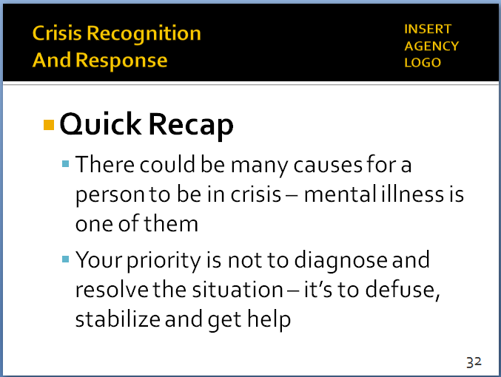

SLIDE #33
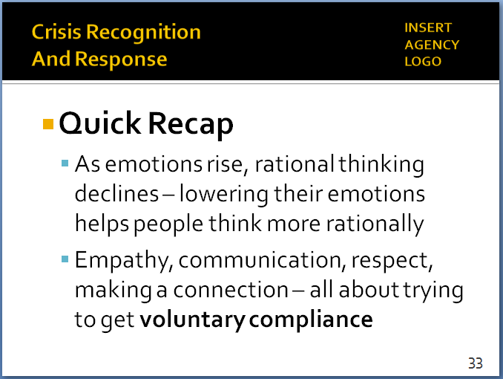

SLIDE #34
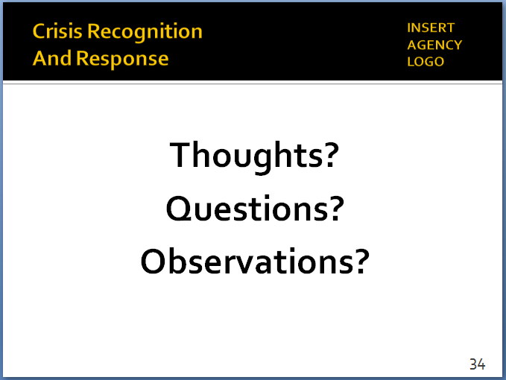

  - Quick recap
  - Many reasons for a person to be in crisis (or a combination of reasons)
    - Mental illness is one of them (but not the only one)
    - Officers need to be on the lookout for a number of reasons a person may be behaving erratically
  - Your priority is not to diagnose the person and try to resolve the situation immediately
  - Priority is to defuse, stabilize and get additional resources who can help you to the scene
- Emotional-rational thinking scale
  - As emotions rise, rational thinking declines
  - Lowering someone’s emotions can help them think more rationally and make better decisions
  - Won’t always be possible, but almost always worth a try
- How?
  - Through empathy, communication, showing respect, slowing things down, trying to make a connection
  - All about trying to get voluntary compliance, so the use of force becomes less likely or unnecessary
- Any thoughts, questions, observations?
  - Review any agency-specific policy considerations not previously discussed (as appropriate)
- Distribute class evaluations of the module (if appropriate)

